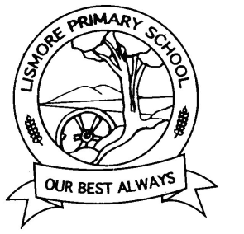
CURRICULUM
POLICY

Rationale:
Implementation of the Victorian curriculum across the school will provide all students with a sequential curriculum framework that guides their learning, as well as providing measures of learning achievement that allow students, teachers and parents the opportunity to assess student performance against standardised learning outcomes.
Aims:
- To improve student learning through the implementation of the Victorian Curriculum across all year levels in a manner consistent with departmental requirements and locally identified needs.
Implementation:
- Our school is committed to the successful implementation of the Victorian Curriculum across all P-6 levels with annual curriculum planning documents developed that reflect this. Staff will collaborate to develop and utilise the scope and sequence documents.
- Classroom teachers are responsible for the development and implementation of curriculum, including the time allocation provided to each of the eight key learning areas with this to be reviewed regularly.
- Priority will be given to time allocation for English (10 hours per week) and Mathematics (5 hours per week).
- Timetabling, where possible, will allocate time to the other six key learning areas (Science, The Arts, Languages, Health and Physical Education, Information and technology and design and technology)
- Curriculum implementation and teaching practice will be reviewed in an ongoing capacity through Peer Observations, Feedback, Professional Development and Professional Learning Community (PLC) meetings.
- Staff will work together in the development and implementation of a strategic plan for the integration of Victorian Curriculum across the school.
- Whole school professional development opportunities will be provided, as well as personal Performance and Development Plans (PDP) developed that align strongly with the School Strategic plan and the Annual Implementation Plans.
- Regular time will be allocated at Staff and PLC’s to share planning, discuss student progress and work on the development of the curriculum across P-6.
- All staff will participate in the collection of student achievement data, and all staff will have input into school decisions resulting from interpretations of these data sets.
- All staff will follow (where applicable) the school’s assessment schedule so to gather the expected forms of data. This schedule will be reviewed annually.
- Data analysis during PLC’s will play a pivotal role in setting goals and targets for outcomes for the individual student, cohort and whole school levels. Individual Learning Plans will use this data to set goals for students achieving 1 year below and 1 year above the expected achievement level.
- Teacher judgements against Victorian Curriculum will be based on the analysis of data available, as set out in the school assessment schedule.
- All Department of Education timelines and reporting requirements will be met.
- Student achievement will be measured and reported to students and parents, with Victorian Curriculum data uploaded to Cases21 at the end of each semester.
- Staff will monitor student progress on an ongoing basis and inform the principal, and parents, of any concerns regarding student achievement against the expected attainment levels.

Evaluation:
This policy will be reviewed as part of the school’s three-year cycle.
This policy was last reviewed on

This policy was last ratified by School Council in....
18th March 2020

